**案例**

**姓名：苏智斌**

**班级：物理三班**

**学号：320170936361**

案例说明：判断农历年是不是自己的本命年

拼接好的模块截图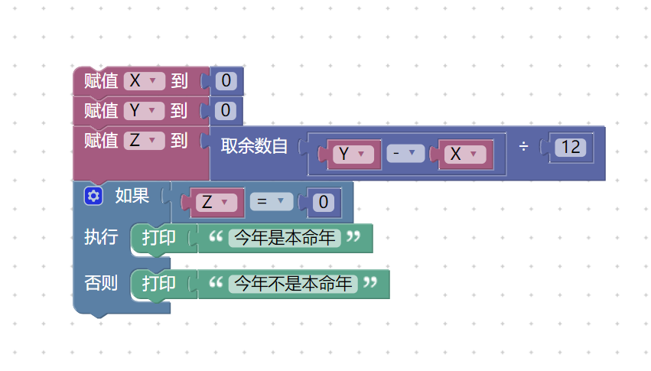

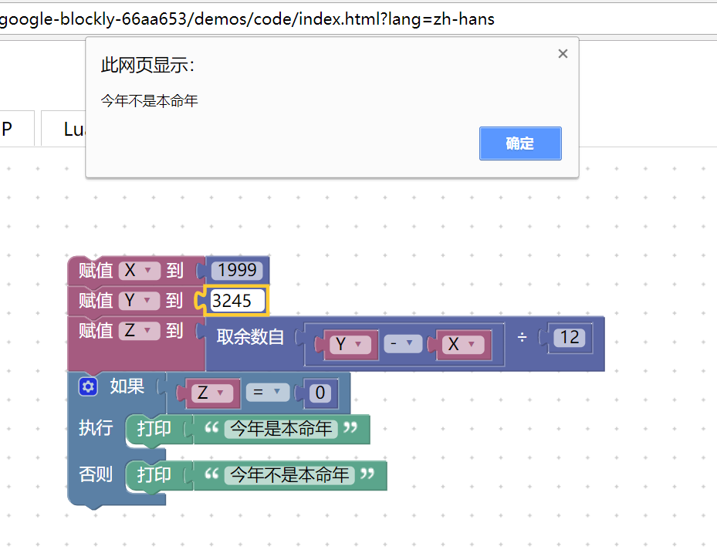运行结果截图： 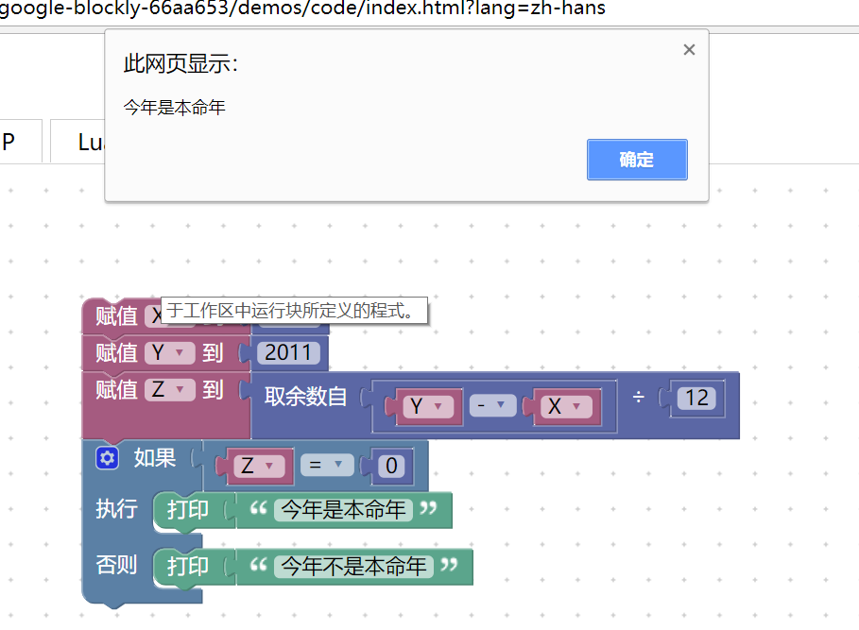

XML：

<xml xmlns="http://www.w3.org/1999/xhtml">

<variables>

<variable type="" id="eCAlg5Kbv-z,637`;7FW">X</variable>

<variable type="" id="IC|`d0Vnf-kvswZ}.XMe">Y</variable>

<variable type="" id="M]l[I|M[mCvJ5u5jzMuH">Z</variable>

</variables>

<block type="variables_set" id="oO+L4#uu5eI1?FeJAMc1" x="13" y="13">

<field name="VAR" id="eCAlg5Kbv-z,637`;7FW" variabletype="">X</field>

<value name="VALUE">

<block type="math_number" id="Z/eQ_0=ro-5U9~JG|XI[">

<field name="NUM">1999</field>

</block>

</value>

<next>

<block type="variables_set" id="~Jy$SXK,Hm$BAr{UZn.?">

<field name="VAR" id="IC|`d0Vnf-kvswZ}.XMe" variabletype="">Y</field>

<value name="VALUE">

<block type="math_number" id="XgCU?Hi$BPV2D!b:}w.7">

<field name="NUM">3245</field>

</block>

</value>

<next>

<block type="variables_set" id="oNU]X{wDG;H*_Q)9)S`G">

<field name="VAR" id="M]l[I|M[mCvJ5u5jzMuH" variabletype="">Z</field>

<value name="VALUE">

<block type="math_modulo" id="@/1k2Y$_h|oc`q@Q(f,u">

<value name="DIVIDEND">

<shadow type="math_number" id="N!_-,i2ip.J{WW{v#nb%">

<field name="NUM">64</field>

</shadow>

<block type="math_arithmetic" id="}0S5LcRH)e0pUN~4@yQq">

<field name="OP">MINUS</field>

<value name="A">

<shadow type="math_number" id="E/nRE?+hbrVd+_++X18Q">

<field name="NUM">1</field>

</shadow>

<block type="variables_get" id="V0*{QBn3.mwupsUBk=`@">

<field name="VAR" id="IC|`d0Vnf-kvswZ}.XMe" variabletype="">Y</field>

</block>

</value>

<value name="B">

<shadow type="math_number" id="+~pOHXp8A:Lb?M?Kj;!0">

<field name="NUM">1</field>

</shadow>

<block type="variables_get" id="hoTOmfYDD9b^bE;N2DvQ">

<field name="VAR" id="eCAlg5Kbv-z,637`;7FW" variabletype="">X</field>

</block>

</value>

</block>

</value>

<value name="DIVISOR">

<shadow type="math_number" id="oS=cD4d,2qdT}p+sPIjR">

<field name="NUM">10</field>

</shadow>

<block type="math_number" id="{.]n)?yap*j`ACBE,;Sg">

<field name="NUM">12</field>

</block>

</value>

</block>

</value>

<next>

<block type="controls_if" id="L=i9EWN+:=uOU1Ga#We!">

<mutation else="1"></mutation>

<value name="IF0">

<block type="logic_compare" id="yf;n2of.,a5Ob9~Qx5B2">

<field name="OP">EQ</field>

<value name="A">

<block type="variables_get" id="G5{I{!4C2CQV_SC8+Ulf">

<field name="VAR" id="M]l[I|M[mCvJ5u5jzMuH" variabletype="">Z</field>

</block>

</value>

<value name="B">

<block type="math_number" id="*yDjy!Z!MKh70;r$~w$*">

<field name="NUM">0</field>

</block>

</value>

</block>

</value>

<statement name="DO0">

<block type="text_print" id="x|{S`.q:$`}M+!(X^5Er">

<value name="TEXT">

<shadow type="text" id=";Uaq39j$ebONvr.IOYDF">

<field name="TEXT">abc</field>

</shadow>

<block type="text" id="mF{s[Q:iDZ0E}fFB.9N^">

<field name="TEXT">今年是本命年</field>

</block>

</value>

</block>

</statement>

<statement name="ELSE">

<block type="text_print" id="yIUQ!0V^hMO[.g^B!atB">

<value name="TEXT">

<shadow type="text" id="ZSZ2PnQ`I8ia^7~}K|w#">

<field name="TEXT">abc</field>

</shadow>

<block type="text" id="0v9Yy%=+!^Gro!$r}iz=">

<field name="TEXT">今年不是本命年</field>

</block>

</value>

</block>

</statement>

</block>

</next>

</block>

</next>

</block>

</next>

</block>

</xml>